Rev. July 2020

On April 10, 2017, Governor Cuomo signed into law “Raise the Age” legislation that was included as part of the State Budget. It can be found in A-3009c/S-2009c Part WWW. Amendments to provisions controlling removal of cases and post-disposition incarceration of youth were codified in 2019 and 2020 and are reflected below.

KEY COMPONENTS OF THE LEGISLATION & SUBSEQUENT AMENDMENTS

The presumptive age of juvenile accountability was raised for 16-year-olds on 10/1/18 and for 17-year-olds on 10/1/19.

The law changed cases for 16- and 17-year-olds in the following ways:

Parental Notification

- Parents must be notified when their children are arrested.
- Questioning of youth must take place in age-appropriate settings, with parental involvement (including with regards to waiving Miranda rights), and for developmentally appropriate lengths of time.

Court Processing

The vast majority of cases of 16- and 17-year-olds have their cases heard in the Family Court, either originating there or being transferred there from the new Youth Part of the adult criminal court.

Misdemeanors:
- All misdemeanor cases (other than vehicle and traffic law misdemeanors) are heard in Family Court pursuant to the Family Court Act. This includes Family Court Act procedures for adjustment and confidential records.

Felonies:
- All felony cases start in the Youth Part of the adult criminal court.
- All non-violent felonies are transferred from the Youth Part to the Family Court unless the District Attorney (DA) files a motion within 30 days showing “extraordinary circumstances” as to why the case should remain in the Youth Part. If DA files motion, there can be a hearing and the Judge must decide within 5 days of the hearing or motions whether to prevent the transfer of the case to Family Court.
- Violent felonies can also be transferred from the Youth Part to the Family Court. If the charges do NOT include the accused displaying a deadly weapon in furtherance of the offense, causing significant physical injury, or engaging in unlawful sexual conduct, the case will transfer to Family Court unless the DA files a motion within 30 days showing “extraordinary circumstances” as to why the case should remain in the Youth Part. If the charge does include an element listed above, removal to Family Court is only possible with consent of the DA. Vehicle and Traffic Law cases and Class A felonies other than Class A drug offenses cannot be transferred.
- If a felony-charged youth is arraigned during off-hours (e.g., nights and weekends when the Youth Part judge is unavailable), the judge hearing the case (known as an Accessible Magistrate) can transfer the case to Family Court with the consent of the District Attorney rather than making the youth come back the following day for the Youth Part judge to make the decision.
- Youth who are 16 or 17 whose cases remain in the Youth Part are referred to as “Adolescent Offenders.” Adult sentencing applies, but the Judge must take the youth’s age into account when sentencing. Adolescent Offenders are eligible for Youthful Offender treatment.
- Adolescent Offenders may voluntarily participate in services while their case is pending.

Violations:
- Violations are heard in adult criminal/local courts. This was not changed by Raise the Age.

Family Court:
- Youth whose cases are heard in the Family Court will be processed pursuant to existing Juvenile Delinquency (JD) laws, which includes the opportunity for adjustment. They will not have a permanent criminal record.

Youth Part of Adult Court:
- The “Youth Parts” of adult criminal court hear the cases of all Juvenile Offenders (aged 13 to 15) and all Adolescent Offenders (aged 16 and 17).
- Youth Part judges have Family Court judge training.

Facilities

- No 16- or 17-year-old can be sentenced to or detained in a facility with adults.
- Youth whose cases are heard in Family Court can be detained or placed in Office of Children and Family Services (OCFS)-operated, OCFS-licensed, or Administration for Children’s Services (ACS) facilities (including Close to Home), as Juvenile Delinquents.
- Adolescent Offenders who are detained pre-trial can be held in a specialized secure juvenile detention center for older youth, which are certified and regulated by OCFS in conjunction with the state commission of correction. Judges have the discretion to order that Adolescent Offenders who are sentenced to less than a year serve such sentences in a specialized juvenile detention center for older youth.
- Adolescent Offenders who are sentenced to incarceration after June 2020 will be placed in OCFS-operated secure facilities. All youth sentenced as Adolescent Offender prior to June 2020 must be transferred from Adolescent Offender facilities operated by the Department of Correction and Community Supervision (DOCCS) to OCFS secure facilities by 10/1/2020.
- Adolescent Offenders sentenced to secure OCFS facilities can remain there until they are 21.

Sealing

- Anyone convicted of an eligible offense in an adult court may seek to have his/her record sealed pursuant to C.P.L. § 160.59 after ten years from the imposition of the sentence or discharge from incarceration, whichever is latest. Violent felonies, sex offenses, and Class A felonies are not eligible offenses. In addition, sealing is only available for people who have no more than 2 convictions, one of which may be for a felony.
- There is no fee for applying, and the application can be found here.

Raise the Age Implementation Task Force

- The Governor appointed a Task Force to coordinate the implementation of these changes.
- The Task Force issued a report required by the legislation in August 2019 on Raise the Age Implementation during the first year, and a second report will follow in 2020.

Effective Dates

- Sealing Provisions: 10/6/17.
- Raise the age for 16-year-ods: 10/1/18.
- Raise the age for 17-year-olds: 10/1/19.
- Sections related to state reimbursement to the counties for probation: 4/1/18.
- Sections related to reimbursement for detention and alternative to detention: 10/1/18.
- Elimination of state support for detained PINS: 1/1/2020.

Youthful Offenders

- The Youthful Offender (YO) laws remain the same.

New York State Assembly Chart Summarizing Court Processing

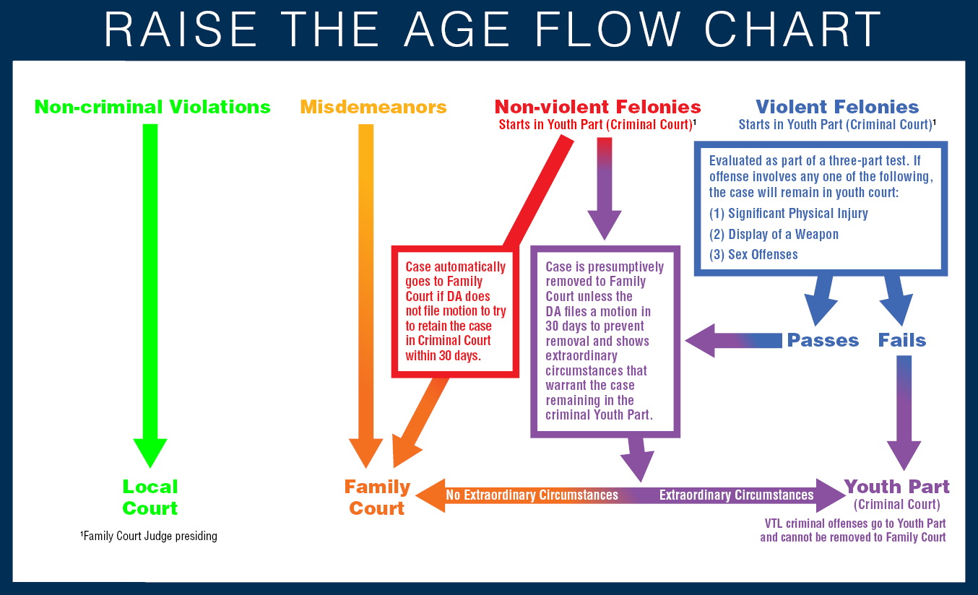

N.Y. Crim. Proc. Law §§ 722.20–21, amended by 2019 N.Y. SB 6550.
N.Y. Exec. Law § 508, amended by 2020 N.Y. SB 7505(g).

